Raman optical amplifier is used for optical signal amplification of ultra-long-distance dense wavelength division multiplexing (DWDM) optical transmission systems.
The product uses multi-pump laser multiplexer technology to achieve gain-flat, low-noise optical signal amplification in the C-band range through a combination of different types of pump lasers and fiber type matching.

For laser safety reasons, the Raman amplifier is designed with an automatic pump laser off function. The laser output can be automatically turned off according to the connection state of the input fiber to ensure personal safety. The product works in ACC mode, which can adjust the working current of the pump laser, and monitor the key information such as pump laser temperature and module temperature in real time.

Features

- Support forward or backward amplifier

- Support 6~10dB Gain

- Support input port fiber connection status monitoring to ensure safety

- Support pump laser operating currency adjustment

Applications
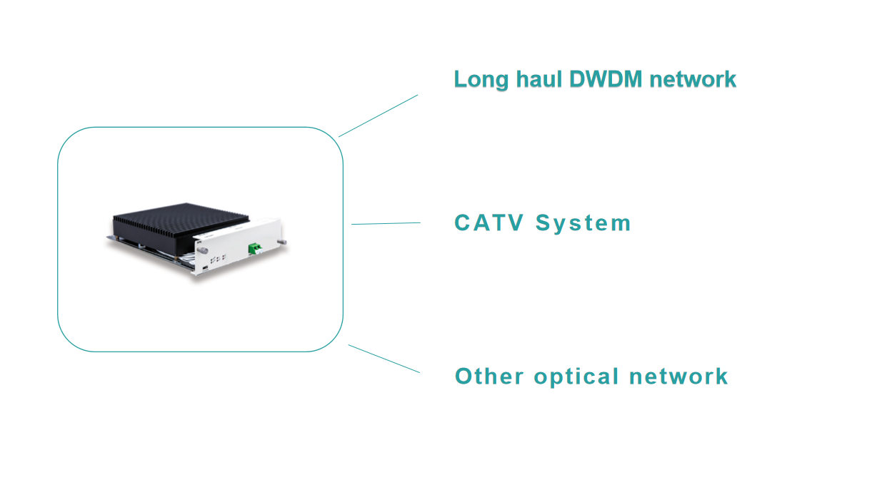

Performance Index

Parameters | Unit | Symbol | Min | Typ | Max
Working mode | ----- | ----- | ----- | ACC | -----
Operating Wavelength | nm | λc | 1528 | 1550 | 1564
Pump Wavelength | nm | λc | ----- | 1425&1455 | -----
Input Power | dBm | Pi | -38 | ----- | -----
On-off Gain | dB | G | ----- | ----- | 10
Noise Figure | dB | NF | ----- | ----- | 3
Flatness | dB | GF | ----- | ----- | 3
PDG | dB | PDG | ----- | ----- | 0.5
PMD | ps | PMD | ----- | ----- | 0.5
Consumption | W | P | ----- | ----- | 25

Memo：Optic connector in default is LC/APC

FAQ:
1.How can I place an order?
(1) Agreement is achieved on the product price and product specifications.
(2) We make proforma invoice for your confirmation.
(3) When you agree on the proforma invoice, you make the payment.
(4) We deliver the goods after we receive your payment.

2. Why do you buy from us instead of another supplier? How to ensure quality?
we support the sample order to test our quality before the bulk order (the sample order cost will be paid by the buyer), and the quality inspection personnel will conduct 100% inspection again before the delivery, so that customers can rest assured to buy.

After-sales Service
- 7x24 Hours
- For product damage not caused by man-made or improper use, we promise a one-year warranty and lifetime maintenance, and the damage caused by unauthorized disassembly of the equipment is not within the scope of warranty and return.
- We promise that the products we provide can meet the performance requirements of the user's products, and are supplied according to the user's consulting sample requirements.

Our factory and team
Team Cohesion Profession Create Value
Take the customer as the center, take the struggler as the foundation, continue to innovate, and never stop !
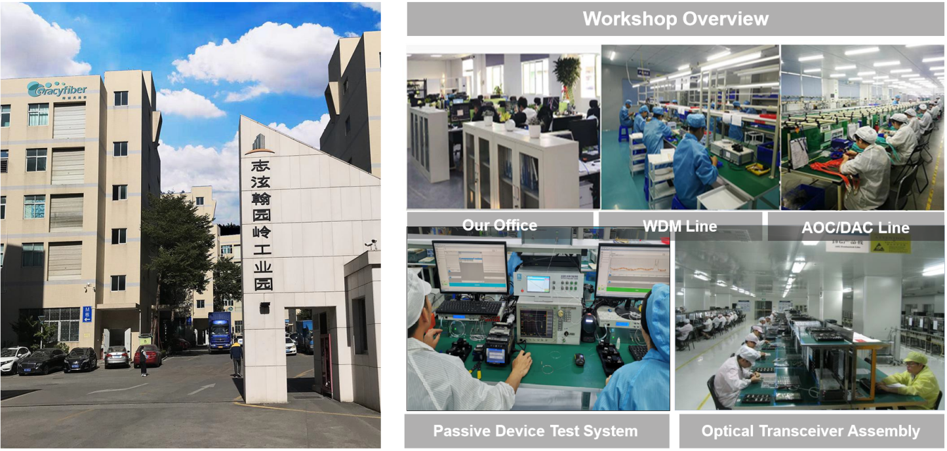

Qualification Certification
