Gracyfiber Standard 19" Rack Mount Chassis can be used for desktop equipment, mounting enclosures. It made of high quality aluminum, customize 19" chassis like 1U, 2U, 3U, 4U, etc. Special custom sizes for different heights. Gracyfiber metal shell can be customized, customers can customize the opening, size, color, logo, etc. Gracyfiber also provide shell solutions, through aluminum shell design and structural design, to suitable project boxes for customers.

Features
- Athermal design operates over operating temperature range
- Large channel number
- Compact size
- High stability and reliability
- Low insertion loss, high isolation increase system margin
Applications
- WDM transmission
- CT-5G
- Metro and long haul network
Specifications
Parameters | Unit | 100G DWDM AAWG Module
Channel | CH | 32 | 40 |  |  | 48
Chip type |  | Gaussian |  |  | Flat Top
Operating wavelength | nm | 1500~1570
Channel Spacing | GHz | 100
Channel Pass band | nm | ITU±0.11
Insertion Loss | dB | Typ≤3.8&Min≤3.5 |  |  | Typ≤6.2 &Min≤5.5
Bandwidth@1dB | nm | ≥0.28 |  |  | ≥0.4
Bandwidth@3dB | nm | ≥0.48 |  |  | ≥0.6
Adjacent Isolation | dB | ≥26 |  |  | ≥23
Non-adjacent Isolation | dB | ≥30 |  |  | ≥29
Non-adjacent Crosstalk | dB | ≥21
Return Loss | dB | ≥45
Directivity | dB | ≥50
Channel Uniformity | dB | ≤1.5
Ripple | dB | ≤1.5 |  | ≤0.5
Polarization Dependent Loss | dB | ≤0.7 |  | ≤0.5
Chromatic Dispersion | ps/nm | ±20
Packaging dimension | mm | 19”1U
Operating Temperature | ℃ | -5~+65

Mechanical Dimensions

19-inch Rack Mount:

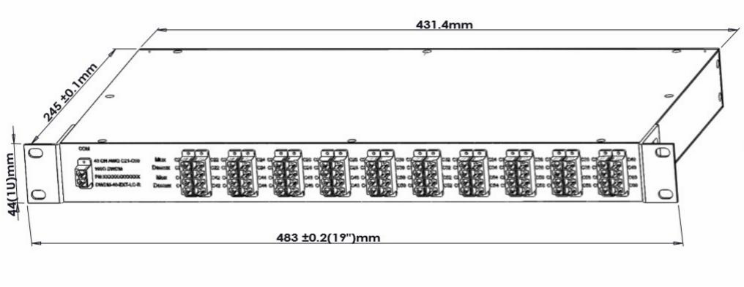

Ordering information

YAWGM | - | ×× | × | × | × | ×× | ××× | - | × | ×
 |  | Package | Module Type | Channel Space | Passband | Channel Number | Start Channel |  | Com | Pass
Y=Gracyfiber |  | 1U=1U | M=Mux | 1=100GHz | F=Flat-top | 32=32 | C17=C17 |  | 0=None | 0=None
A=Athermal
A=Array |  | 2U=2U | D=Demux | 2=50GHz | G=Gauss | 40=40 | C21=C21 |  | 1=FC/UPC | 1=FC/UPC
W=Wavelength |  | ST= Standard | 1=Mux and Demux |  |  | 48=48 |  |  | 2=FC/APC | 2=FC/APC
W=Wavelength |  | Metal Box
G=Grating |  |  |  |  |  |  |  |  | 3=SC/UPC | 3=SC/UPC
 |  |  |  |  |  |  |  |  | 4=SC/APC | 4=SC/APC
 |  |  |  |  |  |  |  |  | 5=LC/UPC | 5=LC/UPC
 |  |  |  |  |  |  |  |  | 6=LC/APC | 6=LC/APC


Shipping Methods

Our computer room construction pictures
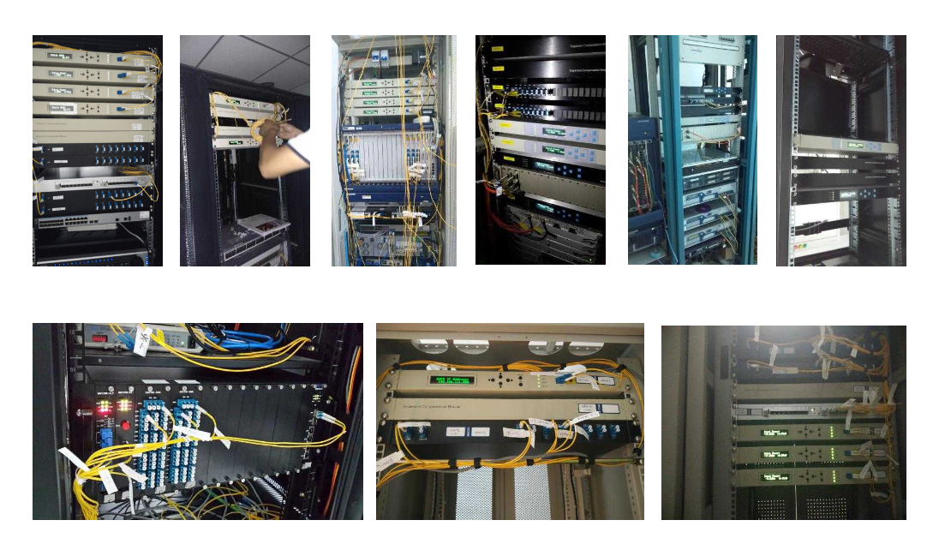
Technology Patent Certificate

