Gracyfiber the product is single-channel EDFA of high stable output. The kernel component of the product is high availability pump laser and high-performance gain flattening filters. The product has high stable output, high gain flatness and high reliability by using unique APC (automatic power control) and ATC (automatic temperature control). The system’s flatness and noise can achieve the best optimization by the gain flattening filters of professional design. The system is convenient to regulation and display, reliable, intelligent by using high stable and high precision MPU

Features

- Low-noise high flatness design

- Adjustable output power

- High precision ATC keep system stable operation

- Precision AGC / APC circuit keeps the output power stability

- Card design highly integrated, space-saving cabinet

- Expansion is very convenient

- Strict accordance with Bellcore GR-1312-CORE requirement for design

Applications

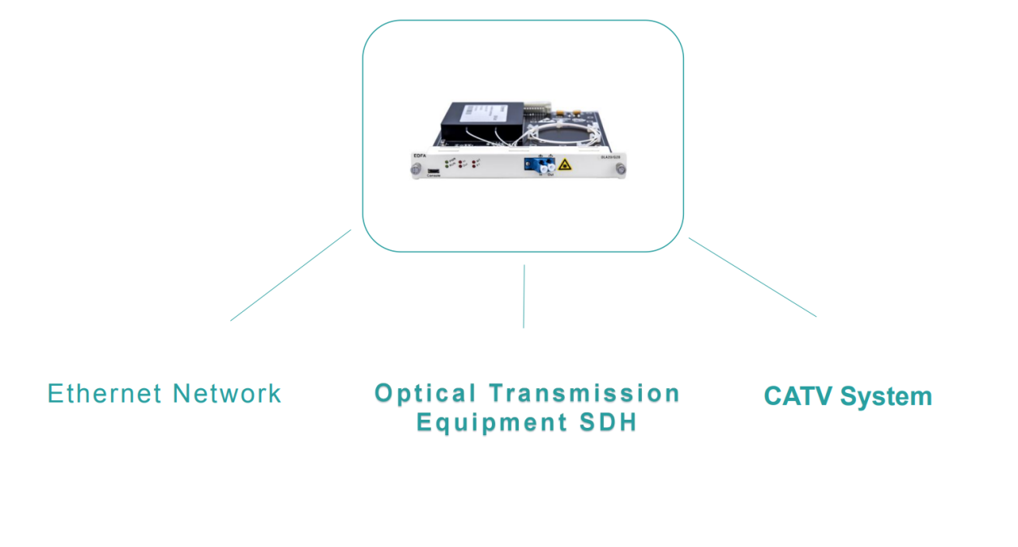

Optical path diagram

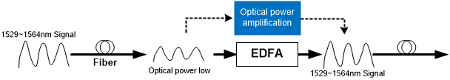

Performance index
BA
Parameters | Unit | Symbol | Min | Typ | Max
Working mode | ----- | ----- | ----- | APC | -----
Operating Wavelength | nm | λc | 1528 | 1550 | 1564
Output Power | dBm | Po | ----- | ----- | 22
Input Power | dBm | Pi | -10 | ----- | 6
Noise Figure | dB | NF | ----- | 4.5 | 6
Power/Gain Stability | dB | ΔPo | ----- | ±0.05 | ±0.1
Input Isolation | dB | ISOi | 30 | ----- | -----
Output Isolation | dB | ISOo | 30 | ----- | -----
Return loss | dB | RL | ----- | ----- | -45
PDG | dB | PDG | ----- | ----- | 0.3
PMD | ps | PMD | ----- | ----- | 0.5
Consumption | W | P | ----- | ----- | 10

PA
Parameters | Unit | Symbol | Min | Typ | Max
Working mode | ----- | ----- | ----- | AGC | -----
Operating Wavelength | nm | λc | 1528 | 1550 | 1564
Input Power | dBm | Pi | -25 | ----- | -10
Gain | dB | G | 8 | ----- | 33
Noise Figure | dB | NF | ----- | 4.5 | 6
Power/Gain Stability | dB | ΔPo | ----- | ±0.05 | ±0.1
Input Isolation | dB | ISOi | 30 | ----- | -----
Output Isolation | dB | ISOo | 30 | ----- | -----
Return loss | dB | RL | ----- | ----- | -45
PDG | dB | PDG | ----- | ----- | 0.3
PMD | ps | PMD | ----- | ----- | 0.5
Consumption | W | P | ----- | ----- | 10

■Laser class information security
Ⅲb level laser products
With single-mode fiber pigtail connectors
Wavelength：0.96~1.68μm
Maximum power：<400mW
Products cannot be transported in a charged state
Note: this instruction outside of any control, regulation and treatment may result in hazardous radiation exposure

Our customers
Our company's supplier group is for the telecommunications industry at home and abroad

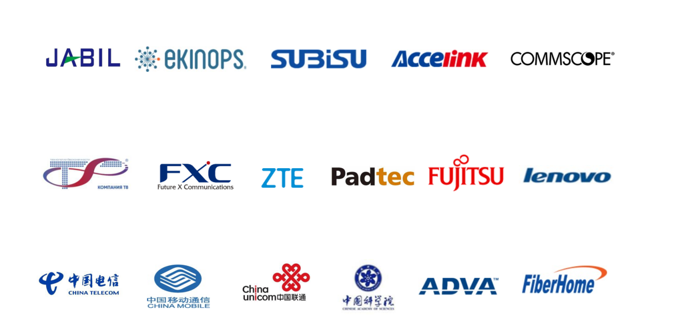
Take the customer as the center, take the struggler as the foundation, continue to innovate, and never stop !

Qualification Certification
