Gracyfiber adopts wavelength division multiplexing (WDM) technology, which greatly improves the transmission capacity of the system. In recent years, wavelength division multiplexing plus erbium-doped fiber amplifier (WDM+EDFA) technology has become the mainstream in the development of high-speed, large-capacity optical fiber communication systems. The Gracyfiber system integrates the monitoring capabilities of optical fiber communication technologies such as WDM, EDFA, and AWG. The wdm system in optical fiber adds EDFA in the c-band, which can be applied to different types of customers and saves a lot of money on user management and maintenance costs.

Features

- Low-noise high flatness design

- Adjustable output power

- High precision ATC keep system stable operation

- Precision AGC / APC circuit keeps the output

- Power stability

- Card design highly integrated, space-saving cabinet

- Expansion is very convenient

- Strict accordance with Bellcore GR-1312-CORE

- requirement for design

Specifications
Item |  | Unit | Technical parameter
Bandwidth |  | nm | 1545~1565
Input optical power |  | dBm | -5 ~ +10
Max output power |  | dBm | 40
Output power stability |  | dBm | ±0.5
Noise |  | dB | ≤ 5.0
Return loss | Input | dB | ≥ 45
Return loss | Output | dB | ≥ 45
Optical connector |  |  | SC/APC&LCAPC
C/N |  | dB | ≥ 50
C/CTB |  | dB | ≥ 63
C/CSO |  | dB | ≥ 63
Supply voltage |  | V | A:AC160V~250V(50Hz);B:DC48V
Consumption |  | W | ≤ 90
Working temperature |  | ℃ | -52
Max relative humidity |  | % | Max 5% no condensation
Storage temperature |  | ℃ | -30 ~ +70
Devise size |  | mm | 464(L)*440(W)*89(H)
Package size |  | mm | 640(L)*640(W)*200(H)

Optical path diagram
Ordering Information

Function | Model
Function | TN1801 | TN1802 | TN1803 | TN1804
Support 40CH MUX&DEMUX | √ | √ | √ | √
Support optical power amplification and automatical adjustment | √ | √ | √ | √
Support 1+1 OLP protection | √ | √ | √ | √
Support 1310 transmission channel | √ | √ | √ | √
Support OSC network management channel | √ | √ | √ | √
Support 40CH service optical power and link optical power monitoring | √ | √ | √ | √
Support dispersion adjustment |  | √ |  | √
Support optical fiber link measurement |  |  | √ | √

Type of packaging
Gracyfiber can provide customized services of labels and packaging according to the different needs of customers


After-sales Service

Data Center Room Construction
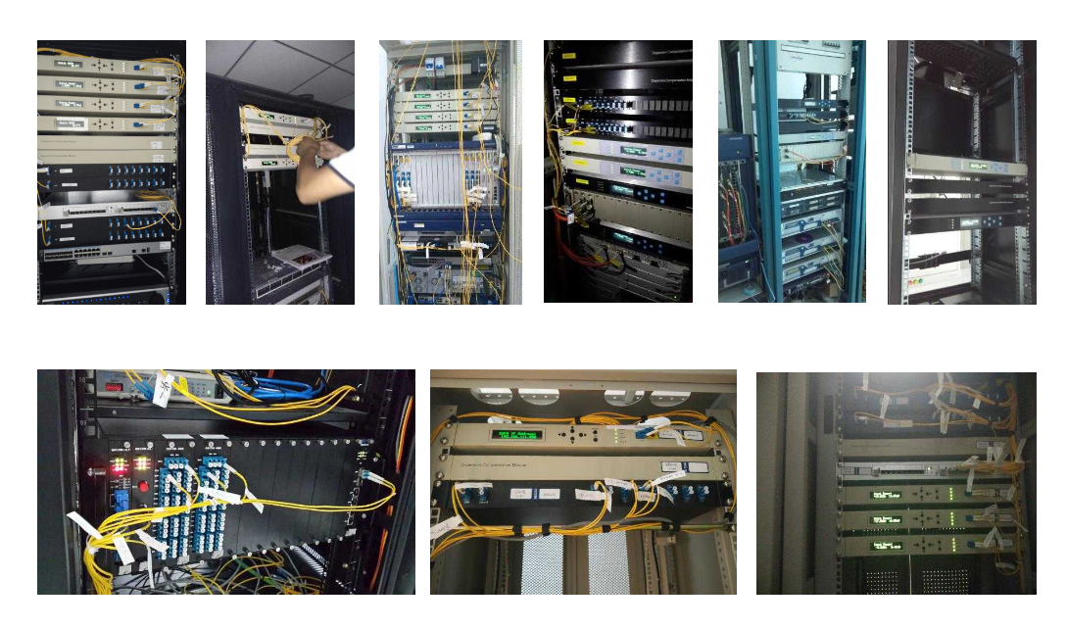

Company Background
Gracyfiber is a high-tech company that provides optical components for global optical communication networks. The company has ten years of experience in R&D and manufacturing of optical devices, and has strong R&D and production technical strength; it has complete and high-precision production testing and testing equipment to provide guarantees for providing high-quality products !

Technology Patent Certificate


