Gracyfiber Coarse wavelength division multiplexer (CWDM) utilizes thin film coating technology and proprietary design of non-flux metal bonding micro optics packaging. It provide low insertion loss, high channel isolation, wide pass band, low temperature sensitivity and epoxy free optical path.

Features
- Low Insertion loss and low PDL
- High channel Isolation
- Good channel-to-channel uniformity
- High Reliability and Stability
- Telcordia Compliant
- RoHS Compliant

Applications
- Broadband networks
- PON Networks
- CATV system
- CWDM system

Specifications
Parameters |  | Unit | 4CH | 8CH | 12CH | 18CH
Operating Wavelength |  | nm | 1260~1620
Channel Space |  | nm | 20
Center Wavelength |  | nm | ITU，ITU+1
Center Wavelength Accuracy |  | nm | ±0.8
Pass band @-0.5dB |  | nm | ±6.5
Port Insertion Loss |  | dB | ≤1.2 | ≤2.5 | ≤3.5 | ≤3.8
Link Loss |  | dB | ≤2.0 | ≤3.2 | ≤4.0 | ≤4.3
Isolation (dB) | Adjacent | dB | ≥30
 | Non-adjacent | dB | ≥40
Ripple |  | dB | ≤0.5
Polarization Dependent Loss |  | dB | ≤0.2

Channel Wavelengths(ITU Grid)
ITU-T G.694.2
Nominal central wavelengths(nm)
1 | 1270 |  | 10 | 1450
2 | 1290 |  | 11 | 1470
3 | 1310 |  | 12 | 1490
4 | 1330 |  | 13 | 1510
5 | 1350 |  | 14 | 1530
6 | 1370 |  | 15 | 1550
7 | 1390 |  | 16 | 1570
8 | 1410 |  | 17 | 1590
9 | 1430 |  | 18 | 1610

Structure Diagram (Refer to the below)
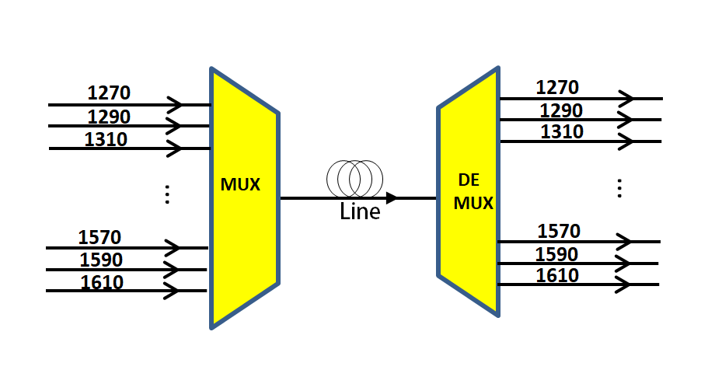

Mechanical Dimensions (Refer to the below)
60*40*11(mm)
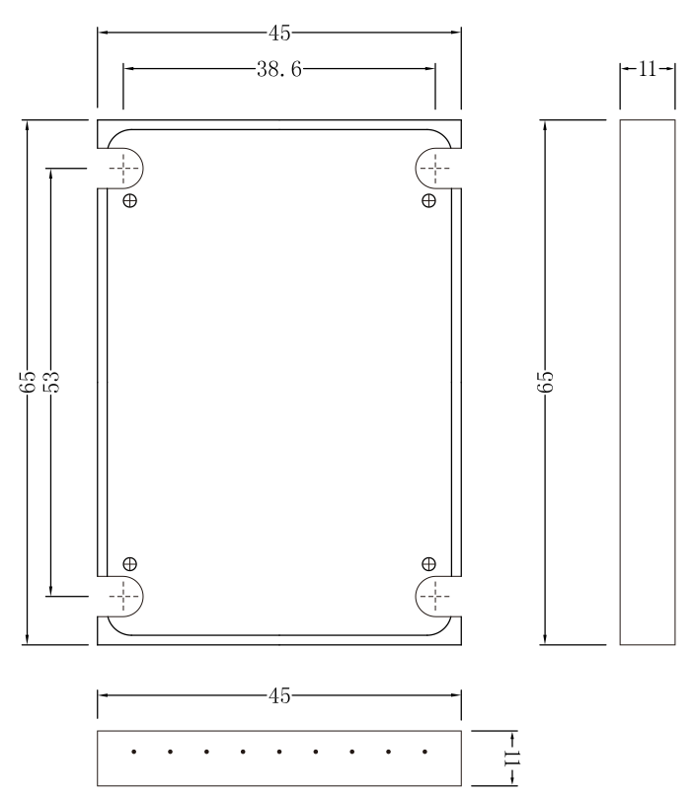

100*80*10mm
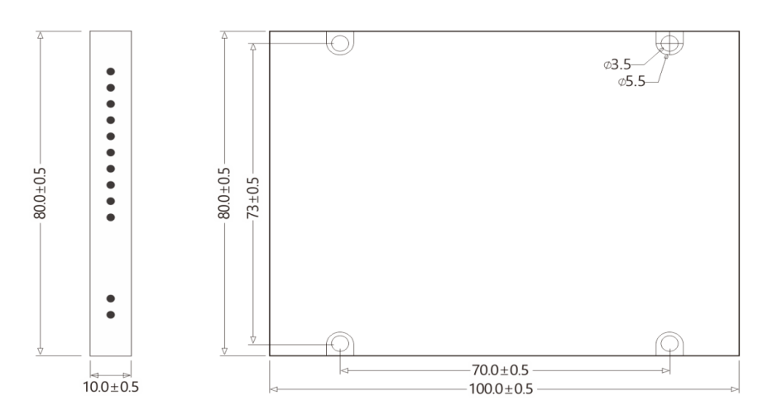
120*80*18mm
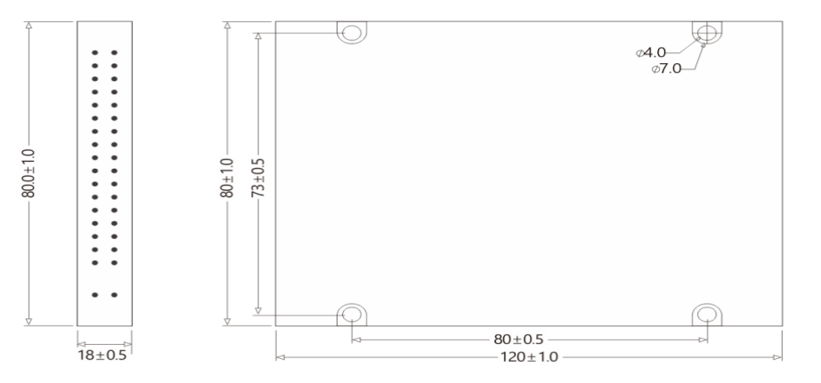

140*115*18mm
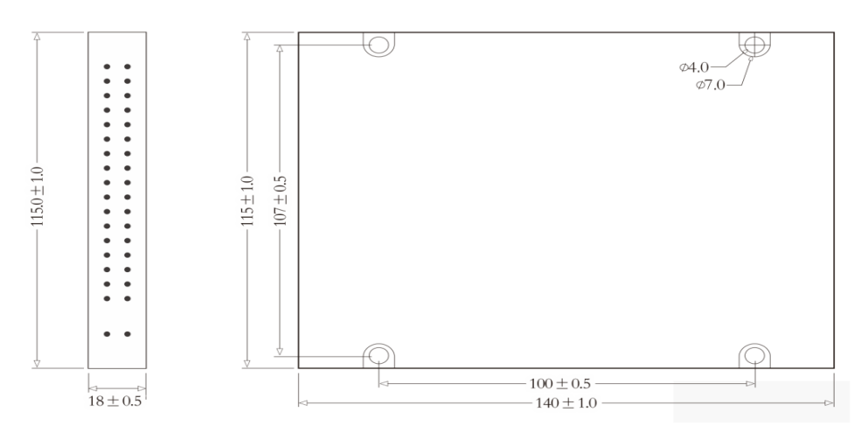

Ordering information
XX | X | XX | XX | XX | XX | - | X | X
Channel No. | MUX/DEMUX Type | Initial CW | Package Type | Fiber Type | Fiber Length |  | Input Connector | Output Connector
04= 02CH | M=Mux | 270= 1270 | SM=65 x45 x11 | 09=0.9mm | 05=0.5m |  | 0=No | 0=No
 |  |  |  | Tube
………… | D= Demux | … | PS=100x80x10 |  | … |  | 1=FC/UPC | 1=FC/UPC
08= 08CH | M&D= | 550=1550 | PM=120x80x18 |  | 10=1m |  | 2=FC/APC | 2=FC/APC
08= 08CH | Mux&Demux
 |  | 551=1551 | PL=140x115 x18 |  |  |  | 3=SC/UPC | 3=SC/UPC
 |  |  | P1=80x58 x8 |  |  |  | 4=SC/APC | 4=SC/APC
 |  |  | X0= Customized |  |  |  | 5=LC/UPC | 5=LC/UPC
 |  |  | SM=65 x45 x11 |  |  |  | 6=LC/APC | 6=LC/APC

Part Number | Product Description
CWDM-18M271PL0905-55 | CWDM Mux Module 1271~1611nm ,18 Port ,
CWDM-18M271PL0905-55 | ABS box(140*115*18mm), 0.5m with 0.9mm White Tube color,
CWDM-18M271PL0905-55 | LC/UPC connectors。

Technology Patent Certificate
